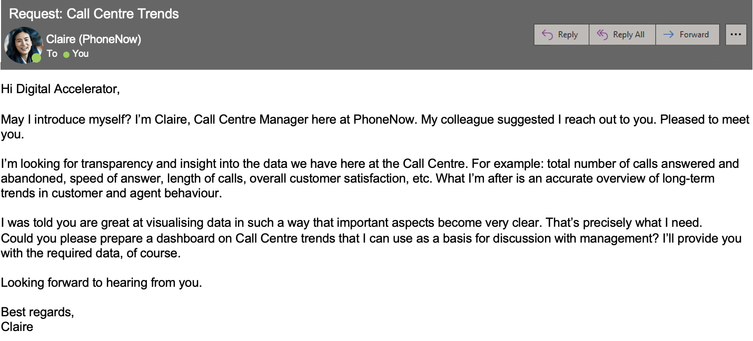

Create a dashboard in Power BI for Claire that reflects all relevant Key Performance Indicators (KPIs) and metrics in the dataset. Get creative!

**Possible KPIs include (to get you started, but not limited to):**

* Overall customer satisfaction
* Overall calls answered/abandoned
* Calls by time
* Average speed of answer
* Agent’s performance quadrant -> average handle time (talk duration) vs calls answered